Test Results Report

Mobile Application

**Shopping List**

com.example.shop_list



**1.Purpose**

This document explains the various activities performed as part of testing the 'Shopping List' mobile application on the Android operating system to provide the testing results and information about the quality of the application.

**2. Application Overview**

The 'Shopping List' application allows the user to create a task list for organizing and managing daily tasks. The user can manage their task list by easily adding, editing, or deleting tasks, as well as marking tasks as completed. All added tasks are saved in the device's local storage. The application does not require a network connection. There are several modules like Adding Tasks, Editing Tasks, Deleting Tasks, Marking Tasks as Completed, Saving Tasks which are integrated to fulfill the purpose.

**3. Testing Scope**

1. **In Scope:**

Functional Testing for the following modules are in Scope of Testing:

* Adding Tasks
* Editing Tasks
* Deleting Tasks
* Marking Tasks as Completed
* Saving Tasks

Localization Testing

* Locale - RU (Russian language)

GUI and Usability Testing

General mobile device compatibility checks:

* Installation Testing
* Interruption Testing
* Working with phone features
* Performance Testing

1. **Out of Scope:**

Cross-platform testing was not performed for this application**.**

Testing on a real device was not performed (Testing was conducted on an emulator).

**c) Items not tested:**

Installation from Play Store – due to the absence the app in the store.

Updating the App – due to the absence the app in the store and new app version.

Installation from a flash drive – due to the absence a real device.

Interruption by connecting headphones – due to the absence a real device.

Interaction with device microphone for voice input of text – due to the absence a real device.

**4. Metrics.**

1. **Test Cases Passes/Failed.**

|  |  |  |
| --- | --- | --- |
| **Test Cases Executed** | **TCs passed** | **TCs failed** |
| 33 | 27 | 6 |

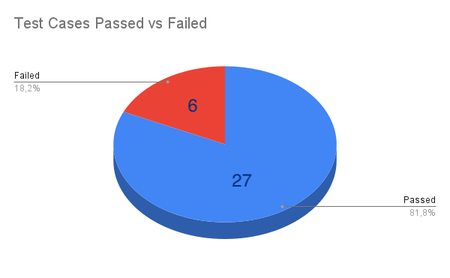

1. **Defects identified and their Status & Priority.**

|  |  |  |  |  |
| --- | --- | --- | --- | --- |
| **Status/Priority** | **High** | **Medium** | **Low** | **Total** |
| **Open** | **0** | **0** | **4** | **4** |
| **Closed** | **2** | **2** | **0** | **4** |

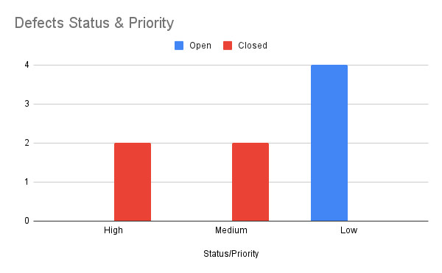

1. **Defects distribution – module wise.**

|  |  |  |  |  |  |  |  |
| --- | --- | --- | --- | --- | --- | --- | --- |
| Priority/Module | Adding Tasks | Editing Tasks | Deleting Tasks | Marking Tasks as Completed | Saving Tasks | Working with device functions | Total |
| High | 1 | 1 | 0 | 0 | 0 | 0 | 2 |
| Medium | 2 | 0 | 0 | 0 | 0 | 0 | 2 |
| Low | 0 | 1 | 2 | 0 | 0 | 1 | 4 |
| Total --> | 3 | 2 | 2 | 0 | 0 | 1 | 8 |

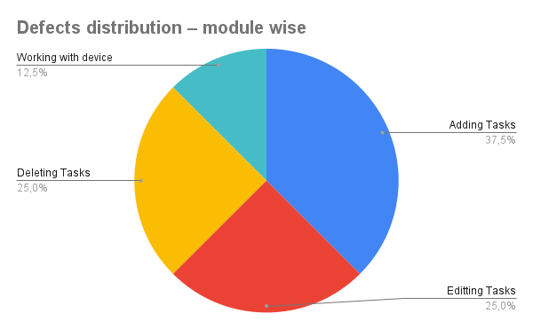

**5. Test Environment & Tools.**

|  |  |
| --- | --- |
| Application package name | com.example.shop_list |
| Integrated development environment | Android Studio Jellyfish | 2023.3.1 Patch 1 Build #AI-233.14808.21.2331.11842104 |
| Emulated device | Pixel 8 Pro API 34, Android 14 |
| Bug Tracking System | YouTrack |
| Test Management System | QASE |

**6. Exit Criteria.**

a) All test cases should be executed – **Yes.**

b) All defects in High, Medium priority should be verified and closed – **Yes.**

c)Open Low defects – Action plan prepared with expected dates of closure.

**7. Conclusion.**

As the Exit criteria was met and satisfied as mentioned in Section 6, this application is suggested to ‘Go Live’ by the Testing team. Appropriate User/Business acceptance testing should be performed before ‘Go Live’.

**Appendix.**

List of defects.

|  |  |  |  |
| --- | --- | --- | --- |
| **Вug ID** | **Summary** | **Status** | **Priority** |
| FTT-1147 | Creating task validation error: Cannot create a task with 25 Cyrillic letters | Closed | High |
| FTT-1149 | Creating task validation error: Creating an empty task containing only spaces is allowed | Closed | Medium |
| FTT-1150 | Editing task validation error: Saving a task with more than 25 Cyrillic letters is allowed | Closed | High |
| FTT-1151 | Editing tasks: When attempting to save an empty task, the editing window unexpectedly closes | Open | Low |
| FTT-1152 | When multitapping the 'Delete' button, the application unexpectedly minimizes to the background | Open | Low |
| FTT-1157 | Localization error: The placeholder in the text field and the delete button are written in English instead of Russian | Open | Low |
| FTT-1159 | Unexpected app minimization when hiding keyboard with virtual keyboard disabled | Closed | Medium |
| FTT-1160 | Task quantity validation error: Adding 11 tasks to the list although only 10 are allowed | Open | Low |